**Requirements:**

* **Max-width** for desktop layout would be **1170px**.
* Use an **open sans** font from <https://fonts.google.com/>
* Use Default font-size **14px**.
* Site name **CEO BLOG** font-size **50px** and font-family **Times New Roman**
* Use **<h1>** tag for largest Heading or page title.
* Use Pseudo classes like **:hover**, :focus and :active etc.
* Use default content from **Lorem Lipsum** <https://generator.lorem-ipsum.info/>
* Make sure your css is error and warning free <http://csslint.net/>
* Make sure your web page is fully **responsive**.
* Make Sure your website is working properly in all **browsers**.
* Don’t Use **Bootstrap** and any other CSS Frameworks.
* Don’t Use any extra **color**, **border**, **background** etc. make it the same as per the design.
* Don’t rename any file on **gitLab**
* Folder Name would be **vb-html-css** on GitLab

Press **Ctrl + Shift + i** for the inspect element of your webpage.

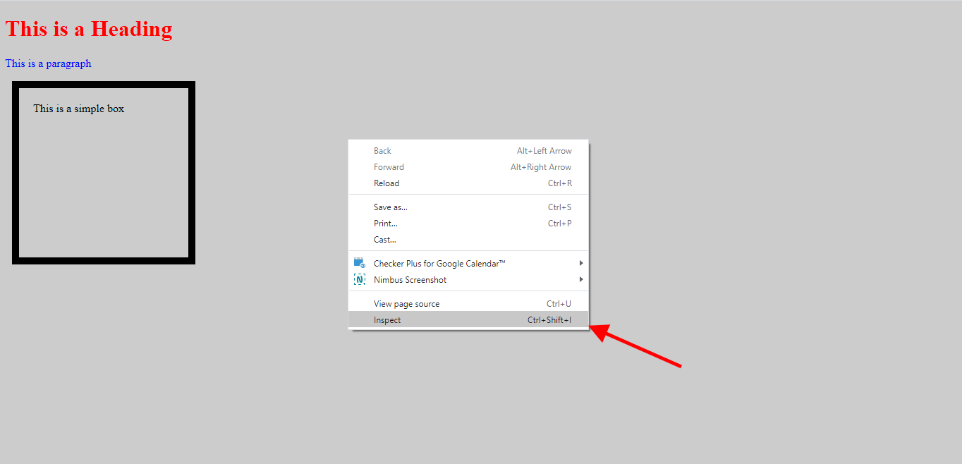

Press **Ctrl + U** for the View source of your webpage.

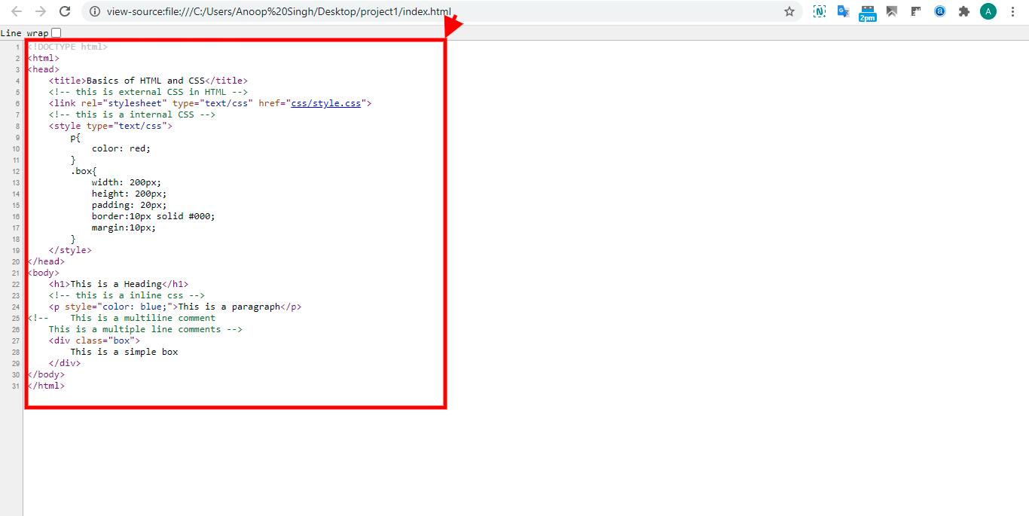

After inspecting the element you can check box sizing and styles of the element.

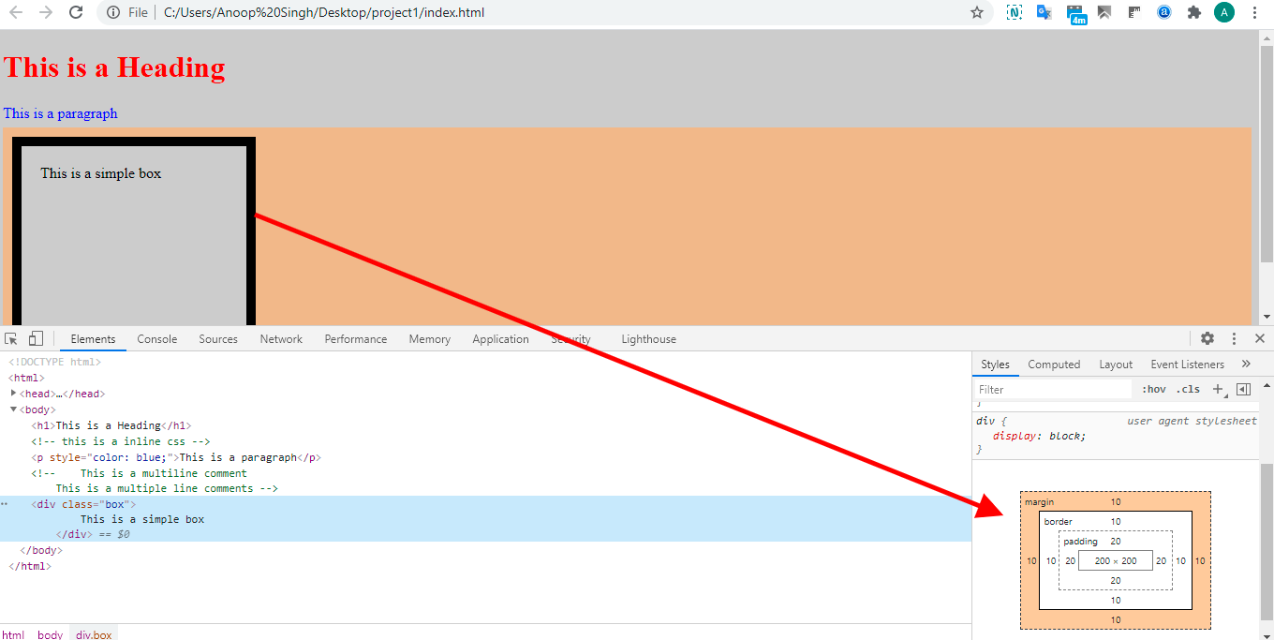

Press **Ctrl + Shift + M** for the Responsive or Toggle Device toolbar.

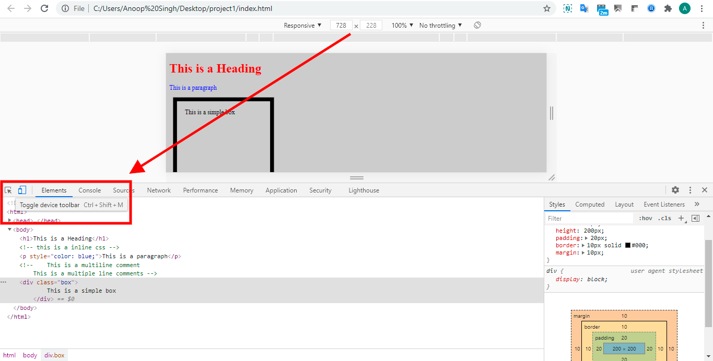

**Follow all the best practices rule:**

* Proper layouting using grid or flexbox
* The right selection of semantic tags
* CSS lint
* Naming Conventions
* Use of Media queries
* Responsiveness
* Frequent git commits with meaningful commit messages
* Meaningful code comments
* Don't use !important in CSS
* Don't add inline styles in HTML
* Avoid usage of ID
* Avoid Extra Selectors
* Use Combine Elements
* Use Multiple Classes
* Use Shorthand
* Make Use of Generic Classes

**Reference:**

HTML Learning: <https://www.w3schools.com/html/default.asp>

HTML Learning: <https://www.tutorialspoint.com/html/index.htm>

CSS Learning: <https://www.w3schools.com/css/default.asp>

CSS learning: <https://www.tutorialspoint.com/css/index.htm>